
BỘ XÂY DỰNG
2026
T RƯỜNG ĐẠI HỌC GIAO THÔNG VẬN TẢI TP.HCM
VIỆN ĐÀO TẠO CHẤT LƯỢNG CAO

----------------

HỌC PHẦN
CÔNG NGHỆ PHẦN MỀM

BÁO CÁO ĐỀ TÀI
LIBRARY MANEGEMENT SYSTEM

. NHÓM 8
Giảng viên hướng dẫn: Trần Thị Mỹ Tiên
Sinh viên thực hiện: Huỳnh Anh Phú – 05420500156 (Leader)
Đinh Phạm Thùy Linh - 060306000050
Lâm Thị Yến Nhi - 072306003845
Đinh Thái Toàn – 089205013267
Nguyễn Thanh Dương - 089206010589
Lớp học phần: 0120121002

I. System introduction
System Objective: The City Library Management System is developed to support digital transformation and improve the efficiency of library operations. The system provides comprehensive tools for managing books, reader profiles, and automating borrowing and returning processes. It also enables quick information lookup and handles overdue cases effectively, assisting librarians in optimizing daily operations.
System Scope: The system is designed for three main user groups:
- Reader: Can search books, view book details, and track personal borrowing history.
- Librarian: Manages books, reader records, and handles borrowing and returning operations.
- Administrator: Oversees the system, manages accounts, configures permissions, and monitors activities.

II. Functional Requirements
- User Authentication and Access Control: The system requires all users to authenticate using their assigned credentials (username and password). Upon successful authentication, the system automatically enforces role-based access control (RBAC) to grant appropriate permissions based on each user’s role. Additionally, users are provided with functionality to update their passwords to ensure account security.
- Book Management: This module enables librarians to maintain and update the library’s collection by adding new book records, modifying existing book metadata, or removing obsolete entries. It also allows users to browse the complete catalog and ensures that the inventory quantity is continuously synchronized with the actual stock.
- Book Search: To facilitate efficient information retrieval, the system provides a multi-criteria search mechanism, allowing users to search by book title, author name, or filter by specific categories/genres. From the search results, users can access detailed book information and check real-time availability status.
- Reader Management: This functionality supports comprehensive management of borrower profiles by allowing the creation of new reader records, updating personal information, and displaying a list of active users. In cases of violations or administrative requirements, librarians and administrators can deactivate or delete reader accounts.
- Borrowing Management: The borrowing process is digitized through the creation of borrowing transactions (borrow slips). When a transaction is initiated, the system automatically validates book availability, records the borrow date, and calculates the due date. It also continuously tracks the status of borrowed items.
- Return Management: When books are returned, librarians confirm the return transaction within the system. The system then automatically updates the inventory count and records the actual return date. In cases of overdue returns, the system triggers the overdue handling process.
- Fine Management: The system integrates an automated fine calculation mechanism for overdue returns. Librarians can update the payment status once the fine is settled, and the entire fine processing history is logged to support auditing and reconciliation.
- Reporting and Analytics: The system provides a variety of reporting features, including statistics on total book inventory, currently borrowed items, and overdue books. Additionally, it generates reports identifying the most active readers based on borrowing frequency, enabling the implementation of targeted engagement strategies.

III. Non-Functional Requirements
1. Usability: The system interface must be designed to be clear, intuitive, and user-friendly for all types of users. Core functionalities should be logically organized and easily accessible. Additionally, the system should be optimized to enable users to perform tasks efficiently with minimal effort and learning curve.
2. Reliability: The system must ensure high data accuracy and maintain a consistent and stable state during operation. It should provide continuous availability without interruption throughout the library’s working hours. Furthermore, a regular data backup mechanism must be implemented to mitigate potential risks of data loss.
3. Performance: Performance is a critical factor; therefore, the book search functionality must provide a fast response time within 1–2 seconds. When handling large datasets (e.g., displaying extensive book lists), the system must remain stable without latency or performance degradation. Moreover, the system architecture should support concurrent access by multiple users without compromising performance.
4. Security: The system must enforce strict and well-defined user authorization mechanisms. All passwords must be securely encrypted in accordance with industry standards. Additionally, appropriate measures must be implemented to prevent unauthorized access and ensure the confidentiality and integrity of user data.
5. Maintainability: The system should be designed using a modular and extensible architecture to facilitate future enhancements and modifications. The source code must be well-structured, maintainable, and organized with clear separation of concerns to support efficient maintenance and scalability.
- Design Constraints: The system operates on a console-based interface (command-line interface – CLI), where all user interactions are performed through a text-based environment. The application is developed using the C++ programming language, focusing on simplicity, efficiency, and ease of implementation.

IV. Data Flow Diagram (DFD)

1. Context Diagram (DFD 0-level)
The overall function of the system is Library Management (Library System). With this system, there are three entities beyond the system’s operational capabilities, including data:
- Độc giả (READER)
- Thủ thư (LIBRARIAN)
- Quản trị viên (ADMIN)
To further illustrate the data exchanges between the system and external entities, the following table provides a detailed description of the Context-Level Data Flow Diagram (DFD):
1.For reader representatives:
- Data streams sent to the system: Login request, Borrow request, Search book keywords.
- Data streams received from the system: Search results, Fine notifications.
2. For the Librarian agent:
- Data streams sent to the system: Book information (Book Info), Member Profiles.
- Data streams received from the system: Overdue Book Reports, Book Status.
3. For the Administrator (Admin) actor:
- Data stream sent to the system: User account information, access permissions.
- Data stream received from the system: Statistical reports.
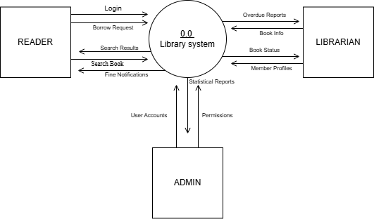

2. Top- level DFD (DFD Level 1)
From the context-level diagram, the Library Management System is broken down into 8 main business processes. Below are the details of the data flows communicating between actors (Readers, Administrators, Librarians) and these processes, as well as the internal data flow:
1. 1.0 Login Management:
- Receive login information (Login) from the reader agent (Reader).
- Verify and return access rights and authentication status to the reader.
2. 2.0 Book Management:
- Receive information about new or needing revisions (Book Info) from the Librarian.
- Return the book update confirmation to the librarian.
3. 3.0 Book Search:
- Receiving keywords and search requests (Search Book) from readers.
- Returns a list of relevant search results to the reader.
4. 4.0 Reader Management:
- Receive reader profile information from the administrator to add or update new readers.
-Provide a reader list for administrators to manage.
5. 5.0 Borrowing Management:
- Receive book borrowing requests (Borrow Requests) from the librarian.
- Create and return the loan slip information to the librarian.
- Internal flow: Forwarding loan slip data (Borrow Slip Data) to process 6.0 to track book returns.
6. 6.0 Return Management:
- Receive confirmation of book return from the librarian.
- Notify the librarian of the book return status (Return Status).
- Internal flow: If a late payment is detected, the system automatically transfers the overdue data to process 7.0 for penalty processing.
7. 7.0 Fine Management:
-Receive confirmation of payment of the fine from the librarian.
- Issue and return the receipt for the fine payment to the librarian.
8. 8.0 Statistical Reports:
- Receive report requests from administrators.
- Compile and return statistical charts and reports for administrators.
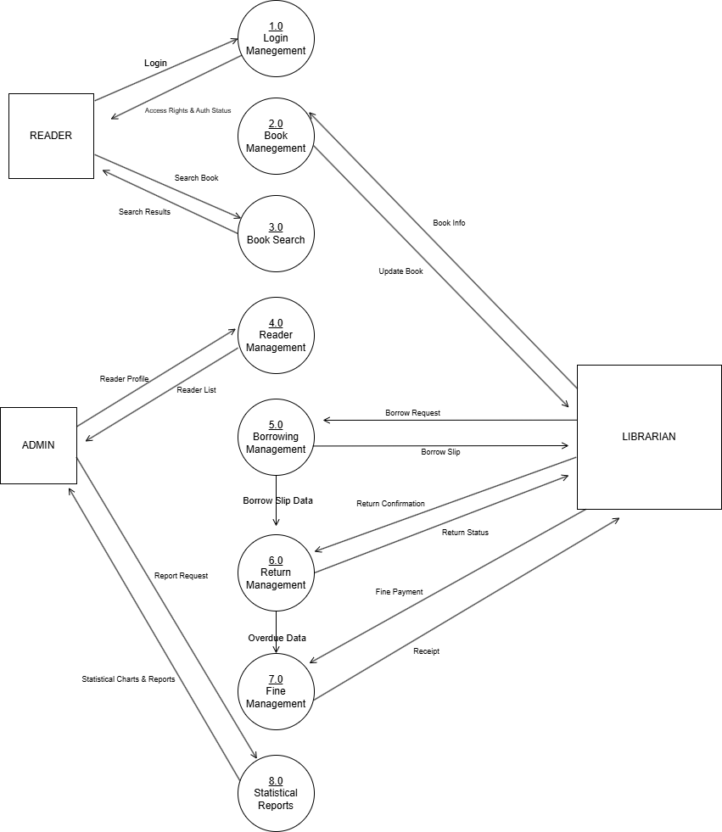

3. Building a Sub-Level Data Flow (Level 2 DFD)
At level 2, the main processes from level 1 diagram are broken down into more detailed subprocesses, clearly showing the internal data flow and direct interaction with data stores. The breakdown details for the 8 business processes are as follows: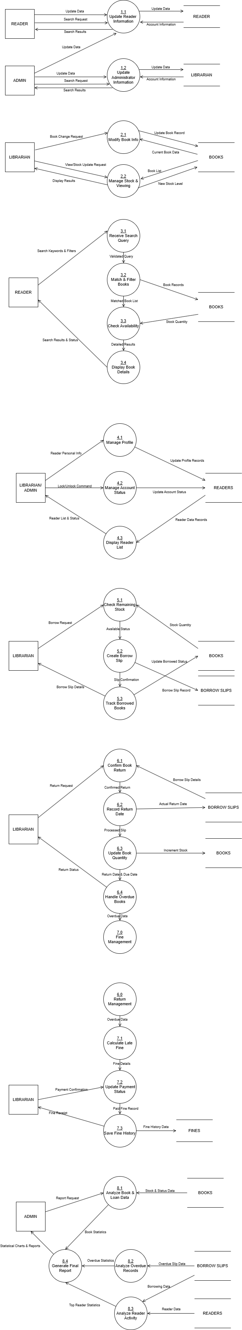
1. Process Segment 1.0 - User Information Management:
-Subprocess: Decomposed into 1.1 Update Reader Information and 1.2 Update Administrator Information.
-Data flow: Reader and Admin agents send requests to update or look up personal information. The system records the new data (Update Data) in the corresponding data repositories, READERS and LIBRARIAN, and extracts personal information to return the results to the user.

2. Process Decomposition 2.0 - Book Management:
-Subprocess: Decomposed into 2.1 Book Information Management (Modify Book Info) and 2.2 Book Inventory Management (Manage Stock & Viewing).
- Data flow: The librarian submits a request to change information or update the number of books. The system retrieves data from the BOOKS inventory for verification, then overwrites the database with the new information (Update Book Record) or the new stock level.

3. Process Analysis 3.0 - Book Search (Book Search):
-Subprocess: 3.1 Receive query, 3.2 Filter books, 3.3 Check inventory status, 3.4 Display results.
- Data flow: This is a one-way query flow. The search request from the reader is analyzed by the system, which extracts book records and stock quantities from the book inventory, then compiles detailed results with availability status (in stock/out of stock) to display on the screen.

4. Decomposing the Industry 4.0 process - Reader Management:
-Subprocesses: 4.1 Profile management, 4.2 Account status management, 4.3 Displaying reader list.
-Data flow: Administrators/Libraries execute commands to add, edit, or lock/unlock accounts. The data is processed by the system and the corresponding status (Update Profile Record / Update Account Status) is directly updated in the READERS repository..


5. Process Decomposition 5.0 - Book Borrowing Management:
-Sub-process: 5.1 Check book inventory, 5.2 Create loan slip, 5.3 Track borrowed books.
-Data flow: When a borrowing request is received, the system checks the quantity of books in the BOOKS inventory. If valid, the system creates a new borrowing record (Loan Record) and saves it to the LOAN inventory, while simultaneously updating the actual quantity in BOOKS to deduct from the actual quantity.

6. Process Analysis 6.0 - Book Return Management:
-Sub-process: 6.1 Confirm payment, 6.2 Record payment date, 6.3 Update quantity, 6.4 Handle overdue payments.
-Data Flow: The librarian verifies the list based on data extracted from BORROW SLIPS. The system records the actual date and automatically accumulates the number of completed books (Increment Stock) in the BOOKS inventory. If the current payment exceeds the limit, the system triggers overdue data (Overdue Data) which is then sent to process 7.0.

7. Process Decomposition 7.0 - Fine Management
-Subprocess: 7.1 Calculate the fine, 7.2 Update the payment status, 7.3 Save the fine history.
-Data flow: Receiving overdue data from process 6.0, the system automatically calculates the penalty fee. Once the librarian confirms payment, the penalty slip status is permanently stored (Fine History Data) in the FINES repository and a receipt is issued to the user.
8. Process Decomposition 8.0 - Statistical Reports:
-Sub-processes: 8.1 Book statistics, 8.2 Analysis of overdue records, 8.3 Analysis of reader activity, 8.4 Generating summary report.

-Data Flow: Receiving commands from the Administrator, the system aggregates large data modules from all three libraries: BOOKS, SLIPS LENDING, and READING. The data is processed and collected into visual statistical charts (Statistical Charts & Reports) and returned to the Administrator.
V. The Agent System
The system is operated by three main agents:
- 1. Reader: A person who uses the library to search for and view information about materials and to borrow books.
- 2. Librarian: This person directly operates the system, is responsible for managing the book collection, reader information, and overseeing the entire borrowing and returning process.
- 3. Admin: This person has the highest authority, responsible for managing the entire system, managing account information, and setting permission levels.
VI. List of Use Cases
Use cases are categorized by actors as follows:
- Reader: Log in, search for books, view book details, and view your personal borrowing history.
- Librarian: Handles book management (Book Management), reader information management (Reader Management), creates new loan slips (Loan Slip Creation), confirms book returns (Return Confirmation), and manages penalty fees (Penalty Management).
- Admin: Performs administrative tasks including user management, viewing summary reports, and adjusting system permissions.

Manage Fine
Reader Librarian Admin
Login Manage Fine Manage Book Manage User
Search Book Manage Reader View Report
View Book Detail Create Borrow Slip Manage Permission
View Borrow History Confirm Return

1. Case using symbols
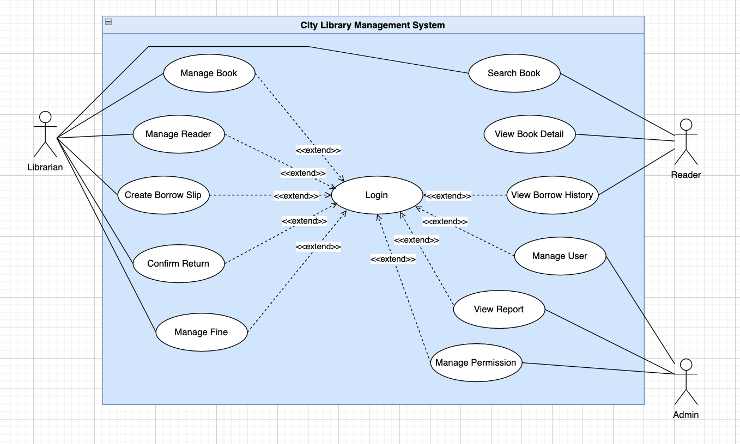

2. Use-case Logi

2.1. Summary

This use case describes how a user logs into the City Library Management System to use functions appropriate to their permissions.

2.2. Event stream

2.2.1. Main line of events
This use case begins when the user selects the login function to access the system.
- The system prompts the user to enter their username and password.
- The user enters their information and is prompted to log in.
- Check that the username and password system is appropriate.
- If the information is valid, the system allows the user to log in according to their corresponding role.

2.2.2. Other event series

Incorrect username or password

If, in the main event flow, the user enters an incorrect username or password, the system will display an error message. The user can choose to re-enter the information or cancel the login attempt, at which point the use case ends.

2.3. Special requirements
- Passwords must be encrypted when stored.
- Only authorized users have legitimate access to the system account.

2.4. System state before the use case begins.

The user is not logged into the system.

2.5. System state after executing the Use-case
- If the use case is successful, the user has logged into the system.
- Conversely, the state system remains unchanged.

2.6. Extension point

Do not have.

3. Use-case Search Book
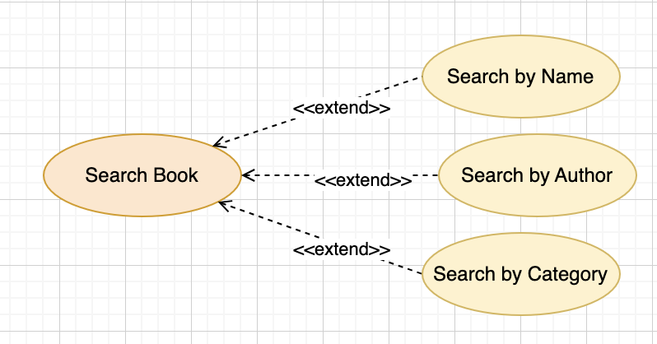

3.1. Summary

This use case allows users to search for books by entering keywords such as book title, author, or genre.

3.2. Event stream

3.2.1. Main line of events
The use case begins when the user selects the book search function.
- The system displays a search keyword input field and filter criteria.
- The user enters the keyword they want to search for.
- The system searches for books that match the criteria provided by the user.
- The system displays a list of matching books.
- Users can select a book from the list to view its details.

3.2.2. Other event series
3.2.2.1. No matching results found If no books match the search criteria, the system will display a "no results found" message.

3.3. Special request
- Search results should be displayed quickly and clearly.
- The system should allow sorting results by book title or author.

3.4. System state before the use case begins.

Do not have.

3.5. System state after executing the Use-case

A list of matching books is displayed to the user.

3.6. Extension point
• Use-case View Book Detail if the user chooses to view book details.

4. Use-case View Book Detail

4.1. Summary

This use case allows users to view the full details of a book in the library.

4.2. Event stream

4.2.1. Main line of events
The use case begins when the user selects a book from the search list or book list.
- The system displays detailed information about the book, including: book code, book title, author, publisher, publication year, genre, available quantity, shelf location, and status.
- Users view the book's details.

4.2.2. Other event series
- Do not have

4.3. Special requirements

• The information displayed must be complete and accurate.

4.4. System state before the use case begins.

The user is currently viewing the list of books.

4.5. System state after executing the Use-case

• Detailed information about the book is displayed.

4.6. Extension point
- Do not have

5. Use-case Manage Book
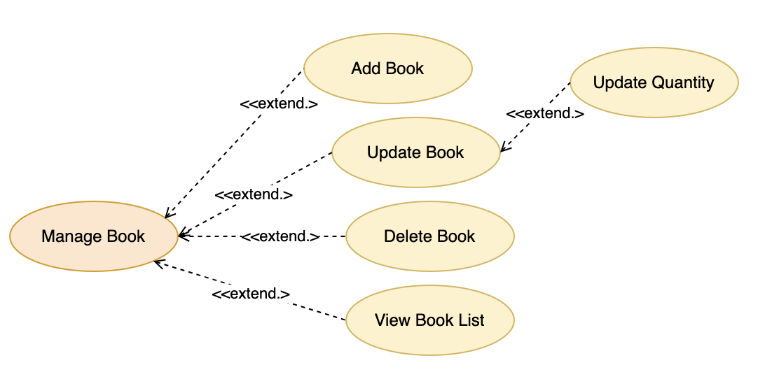

5.1. Summary

This use case allows for managing tutorial mailing lists within the system, including functions for viewing, adding, editing, and deleting lists.

5.2 Timeline of events

5.2.1. Main line of events
The use case begins when the librarian selects the book management function.
- The system displays a list of available books.
- If the librarian selects "Add", the Add Book event is executed.
- If the librarian selects “Update”, the Book Update event is executed.
- If the librarian selects "Delete," the Delete Book event is executed.

5.2.1.1. More books
- The system requires the librarian to enter the book's information.
- The librarian enters the information and provides further confirmation.
- Data validation system.
- The system saves information about new books into the system.
- The system will notify you of additional results.

5.2.1.2. Update books
- The system displaying book information needs updating.
- The book information display system needs to be updated.
- The librarian requests an update to the information.
- Data validation and updating system.
- The system will notify you of updated results.

5.2.1.3. Delete books
- The system requires the librarian to confirm the book deletion operation.
- If the email is confirmed, the system will remove the list from the system..Hệ thống thông báo kết quả xóa.

5.2.2. Other event series

If the entered data is invalid, the system displays an error message and prompts you to re-enter it.

5.3. Special requirements
-Only librarians or administrators are permitted to perform this use-case.

5.4. System state before the use case begins.

-The librarian has logged into the system.

5.5. System state after executing the Use-case
- If the use case is successful, book information is added, updated, or deleted from the system.
- Conversely, the system state remains unchanged.

5.6. Extension point
- Do not have

6. Use-case Manage Reader
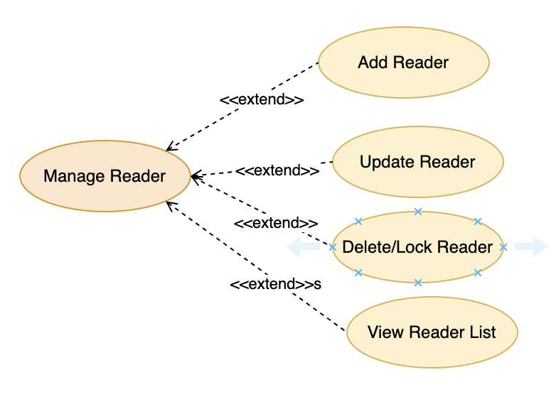

6.1. Summary
This use-case allows the librarian to manage reader information within the library system.

6.2. Flow of Events
6.2.1. Basic Flow
- The use-case begins when the librarian selects the reader management function.
- The system displays the list of existing readers.
- If the librarian selects "Add", the Add Reader flow is executed.
- If the librarian selects "Update", the Update Reader flow is executed.
- If the librarian selects "Delete" or "Lock Account", the corresponding flow is executed.
6.2.1.1. Add Reader
- The system requests the input of reader information.
- The librarian enters the information and confirms the addition.
- The system validates the data.
- The system saves the reader information into the system.
- The system notifies the result of the addition.
6.2.1.2. Update Reader
- The system displays the information of the reader to be updated.
- The librarian modifies the information as needed.
- The system validates the data and updates it.
- The system notifies the result of the update.
6.2.1.3. Delete or Lock Reader Account
- The system requests confirmation for the action.
- If the librarian agrees, the system deletes or changes the status of the reader's account.
- The system notifies the processing result.
6.2.2. Alternative Flows
- If the input data is invalid, the system displays an error message.

6.3. Special Requirements
Only the librarian is allowed to execute this use-case.

6.4. Pre-conditions
The librarian has logged into the system.

6.5. Post-conditions
- If the use-case is successful, the reader data is updated accordingly.
- Otherwise, the system state remains unchanged.

6.6. Extension Points
None.

7. Use-case Create Borrow Slip
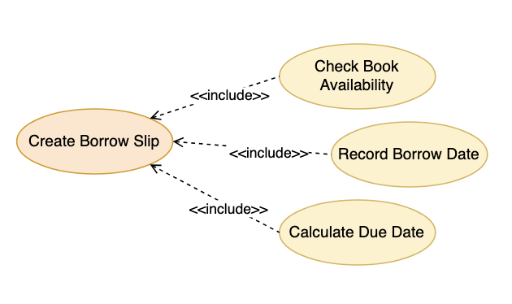
7.1. Summary This use-case allows the librarian to create a borrow slip for a reader.
7.2. Flow of Events 7.2.1. Basic Flow
- The use-case begins when the librarian selects the create borrow slip function.
- The system requests the selection of the reader intending to borrow books.
- The librarian selects the reader.
- The system requests the selection of the books to be borrowed.
- The librarian selects the books and their corresponding quantities.
- The system checks the remaining quantity of the books in the library.
- The system displays the borrow date and due date.
- The librarian confirms the creation of the borrow slip.
- The system saves the borrow slip information and updates the book quantity.
- The system notifies the result of the borrow slip creation.
7.2.2. Alternative Flows
- 7.2.2.1. Insufficient Book Quantity: If the remaining quantity of the books is insufficient for borrowing, the system displays an error message and requests the librarian to reselect.
7.3. Special Requirements A reader is not allowed to borrow exceeding the maximum number of books specified by the regulations.
7.4. Pre-conditions The librarian has logged into the system.
7.5. Post-conditions
- If the use-case is successful, the borrow slip is created and the book quantity is updated.
- Otherwise, the system state remains unchanged.
7.6. Extension Points The reader's fine debt status can be checked before processing the borrow.

8. Use-case Confirm Return
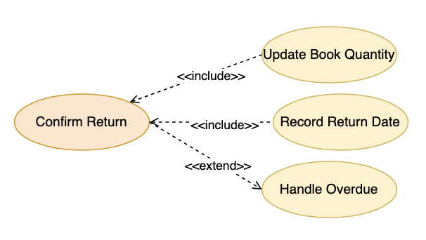
8.1. Summary This use-case allows the librarian to confirm the return of books by a reader.
8.2. Flow of Events 8.2.1. Basic Flow
- The use-case begins when the librarian selects the return book function.
- The system displays the list of currently active borrow slips.
- The librarian selects the borrow slip to be processed.
- The system displays the information of the books to be returned.
- The librarian confirms the return of the books.
- The system records the actual return date.
- The system checks for the number of overdue days, if any.
- If overdue, the system calculates the corresponding fine.
- The system updates the status of the borrow slip and the quantity of books in the inventory.
- The system notifies the result of the book return.
8.2.2. Alternative Flows
- If the borrow slip is invalid or has already been returned, the system displays an error message.
8.3. Special Requirements The fine must be calculated correctly according to the library's regulations.
8.4. Pre-conditions The librarian has logged into the system.
8.5. Post-conditions
- If the use-case is successful, the borrow slip status is updated and the books are recorded as returned.
- Otherwise, the system state remains unchanged.
8.6. Extension Points Use-case Manage Fine if a fine is incurred.

9. Use-case Manage Fine
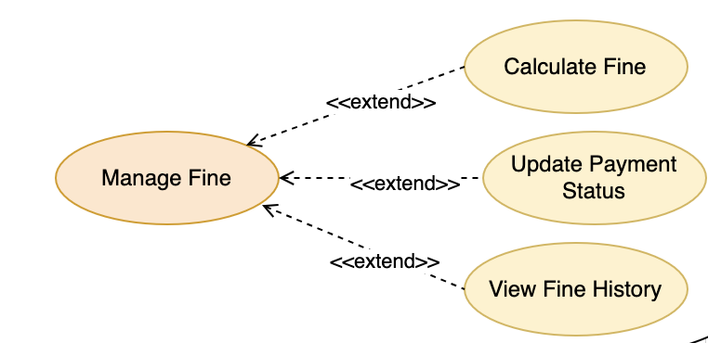
- e payment status update.
- The system validates the information and updates the data.
- The system notifies the result of the update.
9.2.2. Alternative Flows None.
9.3. Special Requirements None.
9.4. Pre-conditions The librarian is currently logged into the system.
9.5. Post-conditions
- If the use-case is successful, the payment status of the fine will be updated in the system.
- Otherwise, the system state remains unchanged.
9.6. Extension Points None.

10.Use-case View Borrow History
10.1. Summary This use-case allows the reader to view their list of borrow slips and their borrowing and returning history within the system.
10.2. Flow of Events 10.2.1. Basic Flow
- This use-case begins when the reader selects the view borrow history function.
- The system displays the list of the reader's borrow slips in descending order, with the newer slips appearing first.
- The reader selects the "View Details" function for a borrow slip.
- The system displays the detailed information of the borrow slip, including the list of borrowed books, borrow date, due date, return date, and the status of the borrow slip.
10.2.2. Alternative Flows None.
10.3. Special Requirements None.
10.4. Pre-conditions The reader must be logged into the system.
10.5. Post-conditions The borrowing history of the reader is displayed. The system state remains unchanged.
10.6. Extension Points None.

11. Use-case Manage User
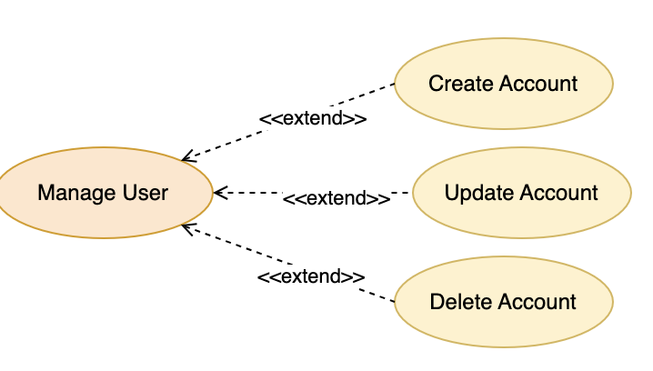
11.1. Summary This use-case allows the administrator to manage user accounts in the system, including viewing, adding, updating, locking, and deleting accounts.
11.2. Flow of Events 11.2.1. Basic Flow
- This use-case begins when the administrator selects the manage user account function.
- The system displays the list of user accounts in the system.
- If the administrator selects "Add", the Add User Account flow is executed.
- If the administrator selects the "Update" function for an account, the Update User Account flow is executed.
- If the administrator selects the "Lock" function for an account, the system updates the account status.
- If the administrator selects the "Delete" function for an account, the Delete User Account flow is executed.
11.2.1.1. Add User Account
- The system requests the administrator to enter the user account information.
- The administrator enters the information and requests the addition.
- The system validates the information and adds it to the system.
- The system notifies the addition result.
11.2.1.2. Update User Account
- The system displays the information of the user account to be updated.
- The administrator proceeds to modify the information as desired.
- The administrator requests the information update.
- The system validates the information and updates it in the system.
- The system notifies the update result.
11.2.1.3. Delete User Account
- The system requests the administrator to confirm the user account deletion action.
- If the administrator confirms the deletion, the system deletes the user account and the information related to this account from the system.
- The system notifies the deletion result.
11.2.2. Alternative Flows None.
11.3. Special Requirements The list of user accounts can be paginated to enhance system performance.
11.4. Pre-conditions The administrator must be logged into the system.
11.5. Post-conditions
- If the use-case is successful, the user account information will be added, updated, locked, or deleted from the system.
- Otherwise, the system state remains unchanged.
11.6. Extension Points None.

12. Use-case View Report
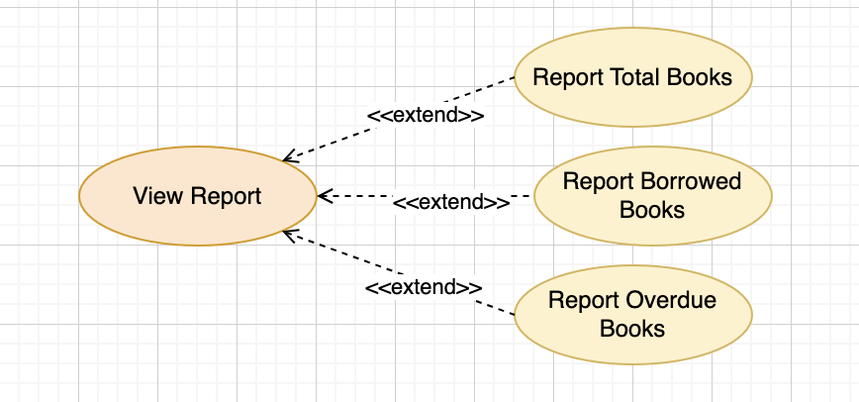
12.1. Summary This use-case allows the administrator to view statistical reports related to library operations.
12.2. Flow of Events 12.2.1. Basic Flow
- This use-case begins when the administrator selects the view statistical report function.
- The system displays a list of viewable report types.
- The administrator selects a report type.
- The system retrieves the corresponding data within the system.
- The system displays the report results to the administrator.
12.2.2. Alternative Flows None.
12.3. Special Requirements The report must accurately reflect the current data in the system.
12.4. Pre-conditions The administrator must be logged into the system.
12.5. Post-conditions The statistical report is displayed. The system state remains unchanged.
12.6. Extension Points None.

VII. Clas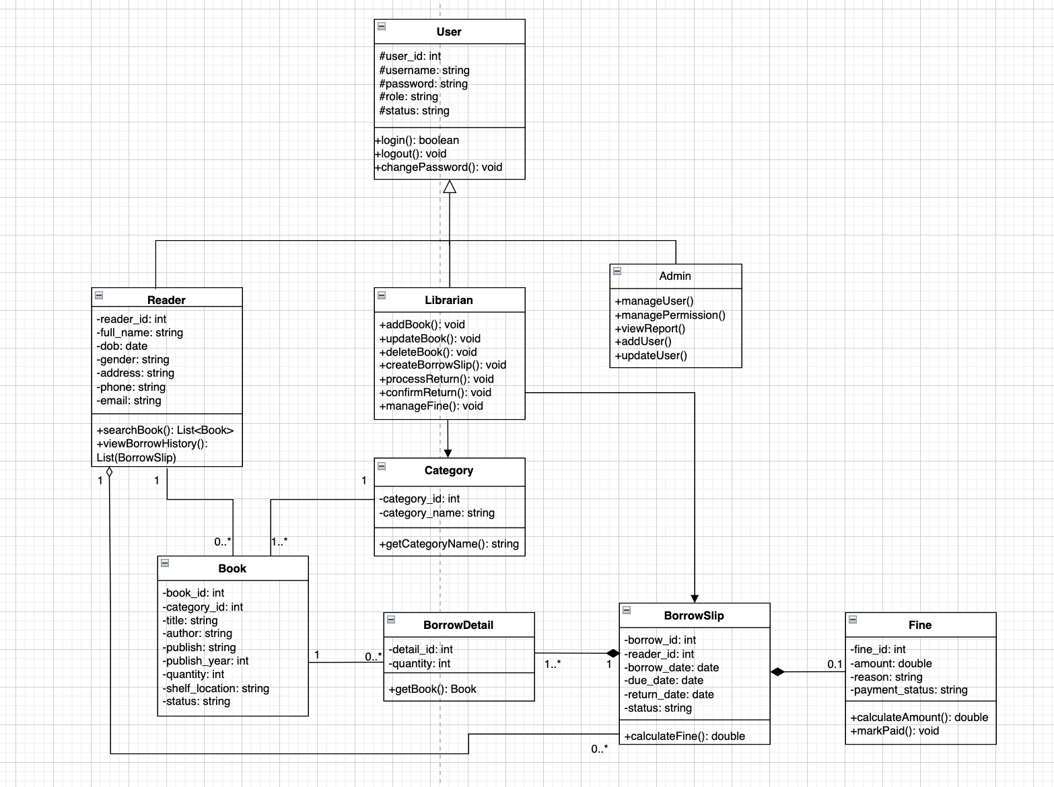s Diagram

Functional Description
1. User Groups (User & Inheritances)
The system utilizes inheritance from the base User class, divided into specific roles:
- User (Parent Class): Manages basic information including ID, username, password, role, and status.
- Common Functions: Includes login, logout, and changePassword.
- Reader: Inherits from the User class. Functions include searching for books (searchBook) and viewing personal borrowing history (viewBorrowHistory).
- Librarian: Inherits from the User class and serves as the primary system operator.
  - Inventory Management: Add, update, and delete books (addBook, updateBook, deleteBook).
  - Circulation Management: Create borrow slips (createBorrowSlip), and process or confirm book returns (processReturn, confirmReturn).
  - Violation Management: Manage fines for overdue or damaged books (manageFine).
- Admin (System Administrator): Inherits from the User class.
  - System & Personnel Management: Manage users (manageUser) including adding, editing, and managing Librarian and Reader accounts.
  - Permissions & Reporting: Manage permissions (managePermission) and view statistical reports (viewReport).
2. Book Management (Book & Category)
- Category: Classifies books by genre (e.g., Science Fiction, Politics). One category can contain multiple books.
- Book: Stores detailed information such as title, author, publisher, publication year, shelf location, quantity, and status.
3. Borrowing & Returning Operations (Borrow & Fine)
- BorrowSlip: Stores general transaction data: borrowing date, due date, actual return date, and slip status. It includes a function to calculate overdue fines (calculateFine).
- BorrowDetail: An intermediary class connecting BorrowSlip and Book. One slip can contain multiple details (different books), with each detail specifying the quantity borrowed.
- Fine: Generated upon violations (late returns or damaged books). It records the fine amount, reason, and payment status.
- Functions: Calculate the violation amount (calculateAmount) and confirm payment (markPaid).

System Relationships
- Inheritance: Reader, Librarian, and Admin inherit from User.
- Association: * Reader - Book: A reader can borrow many books; a book is borrowed by one reader at a time.
- Aggregation:
  - Category - Book: One category contains many books, but a book belongs to only one category.
  - Reader - BorrowSlip: A reader can have many borrow slips; a slip belongs to only one reader.
  - Book - BorrowDetail: A book can appear in many borrow details, but a detail refers to only one book.
- Composition:
  - BorrowSlip - BorrowDetail: Many details belong to one slip. If the BorrowSlip is deleted, the BorrowDetail is also removed.
  - BorrowSlip - Fine: A slip can have 0 to 1 Fine. Without a BorrowSlip, no Fine can exist.
VIII. DATABASE:
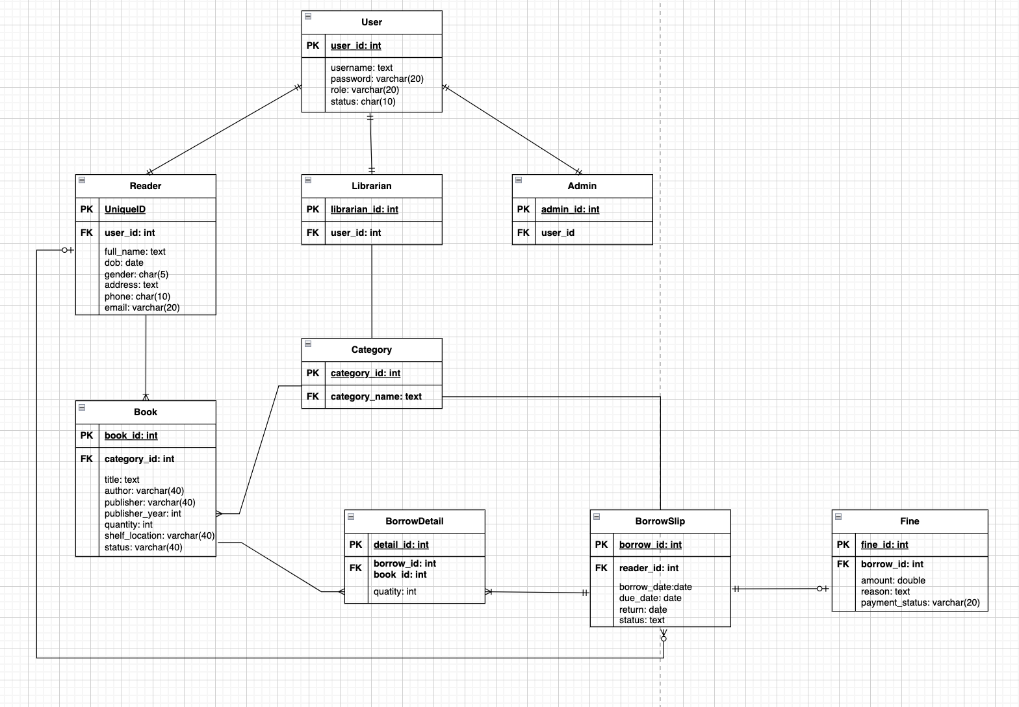

IX. USER INTERFACE (UI) DESIGN
1. User Profiling
- Readers (Novice Users): Requires high-guidance interfaces and layman terms (e.g., "Search Books" instead of "Query Data"). Needs Responsive Design.
- Librarians (Expert Users): Requires processing speed. Prioritizes keyboard shortcuts, minimal mouse usage, and input fields organized by actual workflow.
- Administrators: Requires strict confirmation alerts and high data accuracy.
2. Layout Principles
- F-Pattern: Applied to book searches where users scan from left-to-right and top-to-bottom.
- Grid System: A 12-column grid ensures alignment of buttons and tables for a professional look.
- Visual Hierarchy: Uses font size and weight to highlight critical info like Book Titles or Overdue Notices.
3. Interaction Design (IxD)
- System Status: Uses Loading bars during heavy data processing (e.g., annual reports) to prevent perceived "freezing."
- Error Prevention: Uses constraints like Date pickers for "Borrow Date" to avoid formatting errors.
- State Recovery: Provides Undo or Cancel functions in input forms.
4. Wireframe Specification
- Structural Layer: Defines functional zones like Header, Navigation, Content, and Footer.
- Information Layer: Determines data placement (e.g., Cover image on the left, description on the right).
- Functional Layer: Positions Call-to-Action (CTA) buttons like "Borrow," "Renew," or "Print Receipt."
5. UI Testing Theory
- Compatibility Testing: Ensures correct display across browsers (Chrome, Firefox, Edge).
- Usability Testing: Simulates user scenarios to measure completion time and click counts.
6. UI Components Specification
- Navigation System: Uses multi-level Sidebars/Top Nav and Breadcrumbs (e.g., Home > Inventory > Children's Books).
- Input Controls: Includes Auto-complete Search and Dropdowns/Comboboxes for categories and status.
- Feedback Components: Uses Toast Messages/Snackbars for success alerts and Modal Dialogs for critical confirmations (e.g., "Confirm Delete?").
7. Accessibility & Responsiveness
- Responsive Design: Uses grid systems for seamless scaling between Desktop (Librarians) and Mobile (Readers).
- Accessibility (A11y): High color contrast for the elderly and Alt-text for book covers to support screen readers for the visually impaired.
8. Wireframe to Prototype Workflow
- Sketching: Rough paper layouts.
- Wireframing: Low-fidelity skeletal structures.
- Mockup: High-fidelity designs with actual colors and typography.
- Prototyping: Linking screens to simulate actual user flow.
9. UI Versioning & Management
- User Feedback: Adjusting designs based on user input post-wireframe.
- Version Control: Archiving design iterations to allow for Rollbacks if necessary.

